Appendix G

IRRIGATION MANAGEMENT WITH LIMITED WATER

The following document on stretching irrigation water supplies may be useful to your district’s patrons and can be part of district provision for on-farm irrigation scheduling, provided that the measure is feasible and appropriate for your district in ensuring the efficient use of water and prevention of waster under 690-086-0250 (6e). It is not necessary for an irrigator to take a field completely out of production when the water supply is inadequate to meet crop demands. The Extension Bulletin included below is designed to assist irrigators with planning and management during drought or other circumstances of limited water supplies.

Also included at the end of this document is an Irrigation System Walk-Through Inspection Analysis. This inspection will help identify components that need maintenance, repair, replacement, or other attention.

Stretching Irrigation Water Supplies

PNW 323 • Revised 2005
A Pacific Northwest Extension publication (Oregon, Idaho, Washington)
By M. English, Clint Shock, Roberto Nunez and Howard Neibling

[Originally prepared by Walter L. Trimmer, former Extension irrigation specialist, Oregon State University; revised by Marshall English, Extension irrigation management specialist, Clint Shock, Superintendent Malheur Experiment Station, Roberto Nunoz, Hood River Experiment Station, Oregon State University, and Howard Neibling, Extension Irrigation Specialist, Univ. of Idaho]

In a drought, every gallon of water saved is important. There are many places in a typical irrigation operation where water is lost. Here are some prudent management practices that can conserve water and possibly make the difference between making a profit or taking a loss.

Note: These practices are designed for individual farms only. In a river basin, changes in practices have various effects. Greater water use efficiency on one property may actually reduce the amount of irrigation return flows, thereby changing either the amount or the timing of water available to neighboring farms.

Five basic ways
Five general ways to conserve water are: (1) scientific irrigation scheduling, (2) applying the water as uniformly as practical, (3) reducing spray losses, leakage and runoff, (4) changing cultural practices, and (5) partially irrigating some crops.

Another way to conserve irrigation water is to convert flood and furrow irrigation systems to sprinkler and drip systems. In many cases the new pressurized systems will be substantially more efficient than the surface systems. This is a longer range alternative that should be analyzed carefully in times of drought. Investing in new systems when water supplies are uncertain may increase the financial risk in some cases.

Irrigation Scheduling

This is your first step (see PNW 288, Irrigation Scheduling, for more information). Irrigation scheduling helps you determine how much water crops use, when to irrigate, and how much water the soil can store. Use scientific irrigation scheduling to determine when to irrigate, then run the irrigation system only long enough to refill the root zone. Most irrigation systems have the capacity to apply too much water early and late in a season. If you apply too much water, it will percolate below the root zone where it is effectively lost to the crop. If you apply water too frequently the evaporative losses are unnecessarily high. Increase the intervals between irrigations to nearly the maximum for that crop and soil in order to minimize evaporation from wet soil surfaces. For example, if the suggested refill point for potatoes is 65 percent of available capacity, do not irrigate until soil moisture is approaching that level. The AgriMet web page (www.usbr.gov/pn/agrimet) provides accurate estimates of daily water use, and various types of soil moisture sensors are available to help provide ideal irrigation timing.

For side-rolls, hand-lines, and solid set systems, determine how long to run the system by probing to find the depth of water penetration. Probe within a few feet of the lateral, halfway between sprinklers, two or three times during irrigation.

Odd set times may pose problems when a system is run at night and labor is geared to a 12-hour set. Use a time clock to shut off systems automatically. Straighten side-roll systems in daylight so you can easily move them in darkness.

Applying water as uniformly as possible

No irrigation system applies water with perfect uniformity - some areas will be over- irrigated while others are under-irrigated. When water is not applied uniformly, extra water is often applied to a field to get adequate coverage of the driest areas.

Uniform application requires correct nozzle size, sprinkler spacing, and system pressure. Evaluate the irrigation system design and correct any distribution problems, especially if poor uniformity has shown up in previous years.

Use a lateral offset program on side-roll or hand-move systems (Figure 1). This simple practice will reduce the effective lateral spacing by half after two irrigations---enough to raise uniformity about 10 percent and reduce percolation loss by about the same amount (see PNW 286, Stationary Sprinkler Systems, for more information). The only additional equipment required is a short swingline coupled with a little more management of the system.

Be sure that your sprinkler lines all have the same size nozzles and the correct nozzle size. Check all nozzles for wear; replace worn nozzles with new ones.

Use the correct pressure. Know what the best nozzle pressure is for your specific sprinkler spacing, then check the pressure of the sprinkler discharge at the farthest, lowest and highest points. If a lateral rises or falls more than 15 vertical feet, install flow-control nozzles to improve irrigation uniformity.

High winds distort application uniformity. Normally, high winds occur only for short periods of a day or two, so avoid irrigating during these periods. If irrigation water is delivered continuously, you may need an on-farm pond for temporary storage.

Reducing spray losses, leakage and runoff

Keep evaporation and wind drift losses to a minimum by avoiding irrigation during periods of high wind and temperature. Sprinkler losses from a 5/32” nozzle will be about 9 percent in winds of about 5 mph and a temperature of 80°F. These losses will increase to 20 percent if the wind increases to 15 mph. With 15-mph wind and temperatures of 100°F, the losses from evaporation and wind drift can reach 26 percent. Be sure that nozzle size and system pressure give you an application rate that matches the infiltration rate of the soil. Small nozzles have higher losses than large nozzles, but larger nozzles can cause soil sealing and erosion. Practices such as dammer diking, straw mulching, or application of polyacrylamide (PAM) reduce runoff and erosion and enable you to use larger nozzles.

Prevent runoff caused by excess application rates on fine-textured soils (see PNW 287, Irrigation Runoff Control, for more information). Even local runoff that redistributes water within the field contributes to losses when it forms small ponds, then infiltrates the soil and percolates beyond the root zone. Users of center pivot and solid-set systems can apply extremely light rates at frequent intervals to limit surface water movement. This practice, however, increases evaporation. Check water depth. During each application, apply the greatest depth of water that’s possible without runoff or deep percolation.
Runoff can be significantly reduced by tillage practices such as dammer-dikers that create mini-basins along the furrows. Reduce nozzle size on side-roll, hand-move, and solid-set systems to match soil intake rates. (When you do this, you may have to reduce spacing to avoid a reduction in uniformity.)

Inspect for leaks. Poorly maintained irrigation systems may leak more than 10 percent of their water. Inspect flexible couplers, particularly the quick couplers on aluminum pipe. Replace gaskets that have become hard and cracked. Clean out any sand or silt behind the gasket to assure a watertight seal. Be sure to clean sand from automatic drains in center pivots and side-rolls. This sand can keep the drain from closing when you apply pressure.

Surface irrigation:
Apply water uniformly on surface irrigation systems. Make the output of all siphons and gates as uniform as possible. If a shorter surface irrigation is already uniform, shorten

irrigation set times from uniform 12- or 24 hour sets. You may have to make set changes at odd hours of the day or night. Probe the soil to keep track of the “wetted front” to determine irrigation effectiveness.

Applying water uniformly requires moving the water quickly across the field. Larger stream sizes are one way to accomplish this. Large stream sizes by themselves can erode furrows and cause large amounts of runoff, but runoff losses can be minimized by the various methods listed below:
- Irrigate on the “hard” rows compacted by tractor traffic. Consider furrow packing of “soft” rows to improve water advance. However, in fields with low infiltration rates it may be necessary to irrigate in “soft” rows.
- Surge flow irrigation is another way to move water to the end of the furrows quickly. It has been particularly effective in southeastern Oregon. A comprehensive discussion of surge flow irrigation is available on a web site hosted by the Malheur Experiment Station (go to www.cropinfo.net, then go to the list of sites for Water Quality and pick Best Management Practices and scroll down to Surge Irrigation).
- Use “cut-back” irrigation on furrows, corrugation, and border strips to reduce stream sizes when water approaches the end of the field. After the water has advanced most of the way across the field, cut back the flow rate by about half. You can do this by starting two siphons per furrow, then “cutting back” to one, or by partially closing gates or valves. With experience you will learn the level of cutback water flow that will sustain water flow down the length of the furrows.
- Use pump back systems to recapture runoff (see Best Management Practices at www.cropinfo.net). Maybe the most important surface irrigation conservation practice is a tailwater reuse pit or pond. You can reuse water by collecting runoff water at the end of the field and pumping it back to the top of a farm through an inexpensive pipeline. Reused tailwater is usually less expensive, including both equipment and operating costs, than purchasing additional water from an irrigation district. This is true even when water is available. Open-impeller pumps that can pump trash are required for this purpose. The tailwater system does not disrupt regular production practices. Expect water savings between 30 and 60 percent.

Another water conservation technique is to only irrigate every other furrow.

Reduce losses in supply ditches by lining ditches and using gated pipe for the head ditch. Inspect earthen ditch banks for rodent damage, weeds, sediment, and debris that cause water losses. Clean out weeds and trash-but not silt, which provides a natural seal. A clean ditch will lower water delivery losses to infiltration.

Use checks to control erosion in steep ditches. Farm ditch slopes should be no steeper than 1 / 10 foot per 100 feet. This slope limits water velocity in the ditch and prevents scouring the natural silt. Erosion of the ditch can result in excessive infiltration losses.

Changing cropping patterns and cultural practices

Changing cropping patterns can reduce the need for water by selecting crops that require less water. If possible, substitute shorter-season crops into your rotation. Alfalfa, corn, and sugar beets need water all season; but wheat, barley, rye, and some vegetables need water only early in the season. It is also possible to choose varieties of crops with shorter growing seasons. For example, shorter-season corn varieties are available. These varieties do not have as much yield potential, but they are more likely to produce a crop in a water-short year. Depending on the location, a number of crops can produce a respectable yield with only one irrigation near a critical-growth stage, such as flowering (see following section on partial irrigation). Sometimes, the best way to reduce water use is by eliminating the last irrigation of the season.

Don’t overextend the water supply by irrigating too much land; that can result in crop failure. Plant drought-tolerant crops on any remaining un-irrigated land to minimize wind erosion.

Be ready to change. Set realistic yield goals and change your fertilizing program when you expect reduced yields. Use a soil test to avoid excess fertilizer. Over-fertilized crops will suffer greater damage and sharper yield reductions when water is short. Control water-using weeds with a minimum of tillage.

Consider herbicides or mowing rather than tillage. Every cultivation results in the loss of moisture from the soil.

In general, be conservative with crop inputs. Try to keep cash costs low on cropland subject to drought. This minimizes the financial risk associated with drought.

Partial irrigation

When water supplies are severely restricted, net profits can be maximized by partial irrigation of certain crops. Wheat, alfalfa, and other drought-tolerant crops can be safely under-irrigated by 15 or 20 percent. A partial irrigation strategy may involve reducing irrigation adequacy (i.e. reducing the water applied with each irrigation) or concentrating limited water at critical stages of crop development. Large deficits are normally not advisable; deficits on the order of 15 percent are often about optimal. However if water supplies are severely limited, larger deficits may be appropriate for low valued crops.
Some crops that are very sensitive to water stress should not be deficit irrigated at all. Onion yield and market grade are both sacrificed with partial irrigation. Potatoes can be severely affected by stress, particularly during tuber set and development, resulting in unmarketable tubers.

Reducing irrigation adequacy
Reducing the water applied with each irrigation will cause some degree of crop stress in part of the field, but will substantially reduce water lost as deep percolation in the rest of the field. The reduction in yields will be small and the effect on net income will be

negligible if the irrigation deficits are kept to 15 or 20 percent for relatively drought tolerant crops such as alfalfa and wheat.

Because of the non-uniformity of soils and uneven patterns of applied water, some parts of a field will always receive more water than others. Consequently, when most of a field has been fully irrigated parts of the field may still be slightly under-irrigated. The term irrigation adequacy refers to the fraction of a field that is fully irrigated.

Standard irrigation practices are designed for 90 percent adequacy, which means that enough water will be applied to fully irrigate (or actually over-irrigate) about 90 percent of the field while 10 percent will be under-irrigated to some extent. But when water is in short supply profits may be maximized by fully irrigating less of the field. Yields will be reduced in the parts of the field receiving the least water, but research has shown that field average yield reductions may be small while water savings may be significant.
Figure 1 illustrates a case where a 20 percent reduction in water applied to a winter wheat crop resulted in approximately 4 percent reduction in yields.

Don’t schedule irrigations to keep the driest parts of the field (the hot spots) fully irrigated. Instead, focus on areas of the field that represent average conditions and schedule to keep those areas fully irrigated. This approach might be used where field soils are highly variable. In such cases the farm manager must decide what fraction of the field should be fully irrigated based on the distributions of the different soil types and the proportions of the field that would be most adversely affected.

Optimal timing
Concentrating irrigation at critical stages of crop development and withholding water at other times can maximize the productivity of water. The most appropriate times to irrigate depend upon the crop. Examples of crop-specific strategies are:

  - Alfalfa: the productivity of water is greatest early in the season. Yields of alfalfa per unit of water used are highest for the first cutting and decrease with later cuttings. The best strategy is to concentrate irrigations at the beginning of the season (always subject to need, as determined by scientific irrigation scheduling). Figure 2 shows alfalfa yields per unit of water for several successive cuttings in California’s Central Valley.
  - Small grains: the boot, flowering and soft dough stages of growth are most critical. Crop water use between the boot and flowering stages is relatively less productive, and irrigations after soft dough are the least productive. Referring back to Figure 1, the data point labeled T3-C, which had the highest yields per unit of applied water, was irrigated only twice in the season, just prior to boot and at the beginning of flowering.
  - Orchards: the growing season for fruit trees can be divided into three phases, as illustrated in Figure 3. The first phase includes early fruit development (fruit cell division and rapid early fruit growth). The second phase, called the lag phase, is a period of slow fruit growth and relatively greater growth of woody parts of the tree. The third phase is a final period of rapid fruit growth.

Fruit trees, especially stone fruits, are quite sensitive to water stress during the first and third phases, but partial irrigation during the lag phase will generally have little or no impact on fruit production and tree health.
Consequently, when water is in short supply, under-irrigation should be timed to occur during the mid-season (phase II) period. (Note, however, that partial irrigation of cherries during the second phase may be difficult to manage because that phase for cherries is very short, about 2 weeks.)
Irrigation of fruit trees can be also reduced substantially after harvest, but it should not be suspended completely. During that time the canopy produces the reserves that the tree will use the following spring. Severe stress after harvest may weaken the tree for several years and reduce economic potentials. Therefore, in a drought year, it is not advisable to use all available irrigation water during fruit development to produce a good crop in the current year at the expense of tree health in future years

Irrigation scheduling for partial irrigation
When partial irrigation is practiced, whether by reduced irrigation adequacy or strategic irrigation timing, accurate information about soil moisture conditions in the field is especially important. Scientific irrigation scheduling should be implemented with particular care. It is essential that you know what the nominal (full) irrigation requirement is before calculating the partial irrigation requirement. It is recommended that:
    - Both cumulative crop evapotranspiration (ET_{c}) and soil moisture measurements can be used to estimate soil water content. Both techniques are subject to error, and comparing the results obtained with both methods can reveal errors in one or the other that may otherwise go undetected.
    - The soil water content at field capacity should be determined as accurately as possible for any site where soil moisture is measured.
    - Soil moisture measurements should be made at more than one point in the field to be sure that readings are representative of field-wide conditions.
    - For central pivot irrigation at least one soil moisture monitoring point should be located close to the section of the field where each irrigation rotation begins; irrigation scheduling should be keyed to soil moisture at that point to avoid a time lag between when soil moisture reaches the critical point and when water is actually applied. Many center pivots and linear move systems are limited to an application rate of ½ inch or less per day. If part of a field falls below the critical point for irrigation it may be impossible to refill the soil profile quickly.

Figure 1
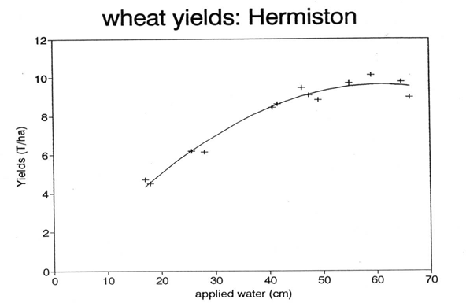
Sensitivity of Winter Wheat to Crop Water Stress When Water Deficits Are Small
- 4% yield

T3-C
- 20%
water

Figure 2
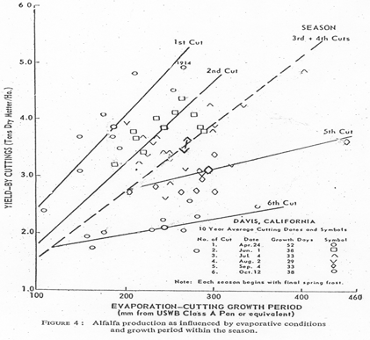
Declining Alfalfa Growth Rates With Later Cuttings

Figure 3
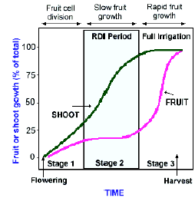
Critical Growth Phases For Fruit Trees (from R. Nunoz)
DI

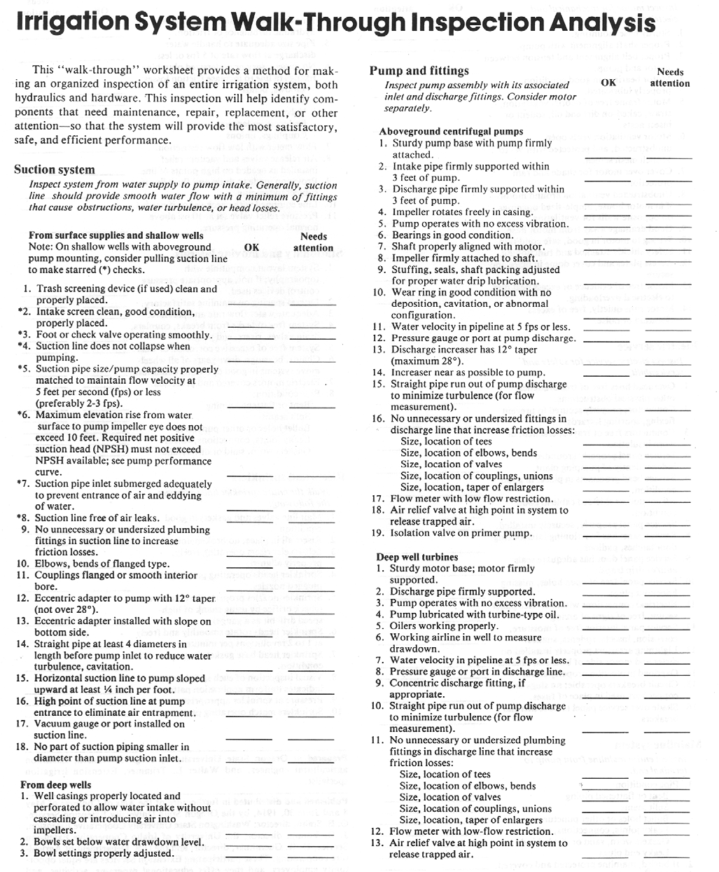

For Further Reading

Hansen, Hugh J., and Walter L. Trimmer, Irrigation Runoff Control Strategies, Pacific Northwest Extension publication PNW 287.

Trimmer, Walter L., and Hugh J. Hansen, Irrigation Scheduling, Pacific Northwest Extension publication PNW 288.

Trimmer, Walter L., and Hugh J. Hansen, Offsets for Stationary Sprinkler Systems,
Pacific Northwest Extension publication PNW 286.

Nishihara, A. and C. Shock. 2001. Benefits and Costs of Applying Polyacrylamide (PAM) in Irrigated Furrows. Available at http://www.cropinfo.net/bestpractices/bmppamreport.html accessed 1 April 2005.

Nishihara, A. and C. Shock. 2001. Cost and Benefits of Surge Irrigation.
Available at http://www.cropinfo.net/bestpractices/bmpsurgereport.html accessed 1 April 2005.

Shock, C.C. 2005. Instrumentation for Soil Moisture Determination. Available at: http://www.cropinfo.net/AnnualReports/1997/instrumentation.wq.html

Goldhamer, D.A. 2003. Managing irrigation in fruit and nut trees during drought. Drought Tip 92-09, University of California, Davis.

Goodwin, I. and Boland, A. M. 2002. Scheduling deficit irrigation of fruit trees for optimizing water use efficiency. In: Deficit Irrigation Practices, FAO Water Report No. 22, Rome.

Contact your local county Extension office for information on obtaining these publications.

